*THE UNIVERSITY OF BUEA*

P.O Box 63  
Cameroon  
Buea South West Region  
Tel : (+237)674354327

FACULTY OF ENGINEERING AND TECNOLOGY  
DEPARTMENT OF COMPUTER ENGINEERING

**REPUBLIQUE DU CAMEROUN**

PAIX-TRAVAIL-PATRIE

MINISTERE DE L’ENSEIGNEMENT SUPERIEUR

c



**BY GROUP 21**

**COURSE INSTRUCTOR** : Dr Nkemeni Valery

ACADEMIC YEAR : **2023/2024**

***CEF440: INTERNET PROGRAMMING AND MOBILE PROGRAMMING***

TASK 1

|  |  |  |
| --- | --- | --- |
| **S\N** | **NAME** | **MATRICULE** |
| 1 | AKENGNI KEANLI EMMANUEL | FE21A132 |
| 2 | CHOMOH SYLVIA FONCHENALLAH | FE21A162 |
| 3 | MBI AYAMBA DIANNA | FE21A230 |
| 4 | NGAUEN NDJOMOU LOICE VANELLE | FE21A258 |
| 5 | NGOBA STEVE JONES NTONSG | FE21A259 |

**Table of Content :**

**INTRODUCTION---------------------------------------------------------------3**

1. **Review and compare the major types of mobile apps and their differences (native, progressive web apps, hybrid apps) ---------------------------------------------------------------------------------------------3**
   1. Review--------------------------------------------------------------------------------------------------------------3
   2. Comparison------------------------------------------------------------------------------------------------------5
2. **Review and compare mobile app programming languages ----------------------------------------------5**
   1. Review--------------------------------------------------------------------------------------------------------------5
   2. Comparison -----------------------------------------------------------------------------------------------------6
3. **Review and compare mobile app development frameworks by comparing their key features (language, performance, cost & time to market, UX & UI, complexity, community support) and where they can be used.--------------------------------------------------------------------------------------------6**
4. **Study mobile application architectures and design patterns --------------------------------------------8**

4-1– Mobile Application Architecture---------------------------------------------------------------------------8

1. Definition---------------------------------------------------------------------------------------------------8
2. Principle----------------------------------------------------------------------------------------------------9
3. Key component-------------------------------------------------------------------------------------------10
4. Deferent Models----------------------------------------------------------------------------------------11

4-2- Mobile Application Design-----------------------------------------------------------------------------------16

1. Mobile architecture Diagram--------------------------------------------------------------------------19
2. Factors to consider during Mobile Apps Designing-----------------------------------------------21
3. Example of Mobile App Design------------------------------------------------------------------------22
4. **Study how to collect and analyze user requirements for a mobile application (Requirement Engineering) ----------------------------------------------------------------------------------------------------------20**
5. **Study how to estimate mobile app development cost. ------------------------------------------------24**

**CONCLUSION---------------------------------------------------------------------------------------------------------25**

**INTRODUCTION**

Today in the digital era , mobile apps have become indispensable tools for businesses across industries . The widespread adoption of smartphones and tables has transformed how organizations operate , communicate and engage with customers. In this report , we will explore the types of mobile apps , their languages , framework , architecture , design and how to estimate it development cost.

1. ***Review and compare the major types of mobile apps and their differences (native, progressive web apps, hybrid apps)***

**1.1 Review**

* **Progressive Webs Apps (PWAs) :**

Definition: PWAs are web applications that use modern web technologies to provide a native app-like experience across multiple platforms.

Key Characteristics:

* Web Technologies: PWAs are built using web technologies such as HTML, CSS, and JavaScript.
* Good Performance: While not as optimized as native apps, PWAs can offer good performance, especially with advancements in web technologies.
* Limited Access to Features: They have limited access to device features compared to native apps but can still utilize features like push notifications and offline capabilities.
* Faster Development Time: PWAs can be developed faster than native apps since they can be written once and deployed across multiple platforms.

Examples: Twitter Lite, Flipkart Lite.

## Native Apps

## Definition: Native apps are developed specifically for one platform, such as iOS or Android, using platform-specific programming languages and tools provided by the platform.

## Key Characteristics:

## Platform-specific Development: Native apps are developed using languages like Swift or Objective-C for iOS and Java or Kotlin for Android.

## Optimized Performance: They offer the best performance as they are optimized for their respective platforms, utilizing platform-specific tools and APIs.

## Access to Device Features: Native apps have full access to device features and APIs, providing a seamless user experience.

## Higher Development Time and Cost: Requires separate development for each platform, resulting in longer development times and higher costs.

## Examples: Instagram (iOS), Google Maps (Android).iOS Mobile App Architecture

## Hybrid Mobile App Architecture

Definition: Hybrid apps are built using web technologies (HTML, CSS, JavaScript) and then wrapped in a native container for deployment on various platforms.

Key Characteristics:

* Web Technology Base: Developed using web technologies similar to PWAs.
* Variable Performance: Performance can vary depending on the framework used and the complexity of the app. While they may not match the performance of native apps, hybrid apps can still offer a satisfactory user experience.
* Access to Features: They can access device features through plugins, but the integration may not be as seamless as with native apps.
* Faster Development Time: Hybrid apps offer faster development time compared to native apps since they can be written once and deployed across multiple platforms.

Examples: Instagram (using React Native), Untappd (using Apache Cordova).

**1.2 Comparison :**

|  |  |  |  |
| --- | --- | --- | --- |
| **Aspect** | **Native Apps** | **Progressive Web Apps (PWAs)** | **Hybrid Apps** |
| **Development Approach** | Developed specifically for one platform | Built using web technologies | Built using web technologies, wrapped in a native container |
| **Programming Language** | Swift/Objective-C (iOS), Java/Kotlin (Android) | HTML, CSS, JavaScript | HTML, CSS, JavaScript |
| **Performance** | Best | Good | Variable |
| **Access to device Features** | Full access | Limited access | Limited access |
| **Development Time** | Longer | Shorter | Shorter |
| **Development Cost** | Higher | Lower | Lower |
| **Platform support** | Platform-specific | Platform-agnostic | Cross-platform |

1. ***Review and compare mobile app programming languages***

**2.1 Review**

* **Swift:**

Description: Swift is the primary programming language for iOS app development, introduced by Apple in 2014. It offers a modern, fast, and safe syntax, making it easier for developers to write and maintain code.

Use Cases: Swift is widely used for developing native iOS apps, ranging from simple utilities to complex applications such as social media platforms and games.

* Objective-C:

Description: Objective-C is the predecessor to Swift and has been the primary programming language for iOS app development before Swift was introduced. It is an object-oriented language with a syntax influenced by Smalltalk.

Use Cases: Objective-C is still used in legacy iOS projects and applications developed before the introduction of Swift. It remains relevant for maintaining existing codebases and supporting older iOS versions.

* **Java:**

Description: Java is a popular programming language known for its portability, flexibility, and robust ecosystem of libraries and frameworks. It is widely used in enterprise applications, web development, and Android app development.

Use Cases: Java is the primary language for native Android app development. It is used to build a wide range of Android applications, including productivity apps, e-commerce platforms, and communication tools.

* **Kotlin:**

Description: Kotlin is a modern programming language developed by JetBrains and officially supported by Google for Android app development. It offers concise syntax, null safety, and seamless interoperability with Java.

Use Cases: Kotlin is gaining popularity among Android developers due to its modern features and developer-friendly syntax. It is used for developing Android apps of various complexities, from small utilities to enterprise-level applications.

* **HTML, CSS, JavaScript:**

Description: HTML (Hypertext Markup Language), CSS (Cascading Style Sheets), and JavaScript are the core web technologies used for building interactive and responsive web applications.

Use Cases: These technologies are used for developing progressive web apps (PWAs) and hybrid apps that can run on multiple platforms using web technologies. They are particularly suitable for applications with web-based content, such as news portals, e-commerce websites, and social media platforms.

**2.2 Comparison :**

|  |  |  |  |  |  |
| --- | --- | --- | --- | --- | --- |
| **Aspect** | **Swift** | **Objective-C** | **Java** | **Kotlin** | **HTML/CSS/JavaScript** |
| **Platform** | iOS | iOS | Android | Android | iOS |
| **Syntax** | Modern, concise | Complex | Familiar, verbose | Modern, concise | Complex |
| **Performance** | Fast | Fast | Fast | Fast | Fast |
| **Safety** | Strong | Moderate | Moderate | Strong | Moderate |
| **Interoperability** | Limited | Full | N/A | Full | Full |
| **Community Support** | Strong | Strong | Strong | Growing | Strong |
| **Use Cases** | Native iOS app development | Legacy iOS projects, maintenance | Native iOS app development | Native iOS app development | Legacy iOS projects, maintenance |

1. ***Review and compare mobile app development frameworks by comparing their key features (language , performance ,cost & time to market ,UX &UI ,complexity , community support) and where they can be used .***

A mobile app development framework is a software framework that provides developers with tools, libraries and pre-written code to streamline the process of building mobile applications. These frameworks are design to facilitate the development of apps for various mobile platform such ass IOS and android.

**Comparison amongst mobile app development frameworks**

|  |  |  |  |  |  |  |
| --- | --- | --- | --- | --- | --- | --- |
|  | LANGUAGE | PERFORMANCE | COST& TIME TO MARKET | UX &UI | COMPLEXITY | COMMUNITY SUPPORT |
| REACT NATIVE | JavaScript | Good performance due to it use of native components | Cost-effective and relatively fast development due to code reusability across platforms | Provides a native-like experience with ability to customize UI component | Large and active community with extensive libraries and resources | Suitable for cross platform development, especially for apps with complex UI requirements |
| FLUTTER | Dart | Excellent performance due to it use of a compile programming language | Cost-effective and fast development with hot reload feature for quick iterations | Offers customizable and visually appealing UI with it own widget library | Growing community with google’s backing and extensive documentation | Suitable for cross platform development, especially for apps requiring high-performance UI |
| IONIC | HTML, CSS, JavaScript/TypeScript | Good performance but may not match native performance for complex apps | Cost-effective and relatively fast development , especially for web developers | Uses web technologies for UI, customizable but may not provide nave-like experience | Large community with extensive plugins and support | Suitable for cross platform development, especially for hybrid apps and MVPs |
| XAMARIN | C# | Good performance with direct access to native APIs | Development cost maybe higher due to licensing, but time to market can be faster | Provides access to native UI component foe a native-like experience | Decent community support with Microsoft backing and documentation | Suitable for cross platform development, especially for enterprise-level app and games |
| NATIVESCRIPT | JavaScript, TypeScript | Good performance with access to native APIs | Cost-effective and relatively fast development with code sharing capabilities | Provides access to native UI component foe a native-like experience | Decent community support with plugins and resources | Suitable for cross platform development, especially for apps requiring access to native APIs |

1. ***Study mobile application architectures and design patterns***

**MOBILE APPLICATION ARCHITECTURE AND DESIGN**

* 1. **Mobile application architecture**

1. **Definition**

Mobile app architecture is the structural design and organization of a mobile application, outlining how various components and modules of the app are interconnected and work together to achieve its functionality

[A well-designed mobile app architecture is important because it can](https://www.bing.com/ck/a?!&&p=f9e34b39c8b5013dJmltdHM9MTcxMTkyOTYwMCZpZ3VpZD0wZWEyOTI0OS1lM2VmLTY5YTEtMzcyZC04MTEwZTIzMjY4ZGImaW5zaWQ9NTgwMw&ptn=3&ver=2&hsh=3&fclid=0ea29249-e3ef-69a1-372d-8110e23268db&psq=importance+of+mobile+app+architecture&u=a1aHR0cHM6Ly9kZWNvZGUuYWdlbmN5L2FydGljbGUvbW9iaWxlLWFwcC1hcmNoaXRlY3R1cmUv&ntb=1)

* Make the mobile app more stable, efficient, and easier to work with.
* Facilitate collaboration and scaling of teams.
* Improve quality and robustness.
* Improve an app’s performance, stability, and scalability.
* Enable easier testing and maintenance and quicker updates when necessary.

1. **Mobile App architecture principle**

When it comes to mobile app development, there are a few key principles that should be followed in order to create a successful and well-designed app.

#### Sustainability

As the world increasingly moves online and mobile devices become more ubiquitous, it’s crucial for developers to create applications that are sustainable. In the context of mobile app development, this means creating apps that are efficient in terms of both energy and resources. One way to make sure your app is sustainable is to use a [content delivery network](https://en.wikipedia.org/wiki/Content_delivery_network) (CDN). CDNs help to reduce latency and improve performance by caching content locally. This can help to reduce both data usage and energy consumption.

Additionally, using recycled materials for your app’s packaging can also help to reduce your app’s environmental impact. Think about how long the system will be able to continue operating without needing major overhauls. This can be achieved by using established design patterns, employing modularity and abstraction, and using standardized interfaces. By following these principles, architects can help ensure that their systems are sustainable and can stand the test of time.

#### Maintainability & Manageability

These characteristics specify how quickly and readily applications may be improved, monitored, and optimized. It includes tools and techniques for creating mobile apps that give developers the ability to manage app security logs, record system issues, and faults, maintain app improvement plans, guarantee top performance, and much more.

First, the code should be clean and well-organized. This will make it easier for other developers to understand it and work with. Second, an app should be designed with extensibility in mind. This means that adding new features or modifying existing ones should be easy without breaking an app. Finally, an app should be tested thoroughly before release. This will ensure that any bugs are found and fixed before users encounter them.

#### Reusability

In order to create a successful and sustainable app, it is essential to reuse as much code as possible. Not only does this help to cut down on development time, but it also reduces the chances of errors and can make maintenance easier. Any effective architecture incorporates the reusability component, which guarantees a shorter time-to-market for the introduction of new software versions and updates.

One common approach is creating a library of reusable components that can be used across different app parts. Another approach is to use a software framework that provides a set of core components that can be extended and customized as needed.

#### Security

When it comes to security, there are two primary considerations for mobile app developers: data security and user authentication. Data security is essential for protecting sensitive information such as customer credit card numbers and health records. There are a variety of ways to secure data, including encryption, password protection, and access control.

User authentication is another important consideration, as it helps to ensure that only authorized users can access confidential information. Various authentication methods are available, including biometrics, one-time passwords, encrypting data , and two-factor authentication. By incorporating these [app security measures](https://forbytes.com/blog/application-security/) into their mobile app architectures, developers can keep customer data safe and secure.

#### Performance

One of the most critical performance principles is to keep it simple. Complicated architectures can lead to performance issues such as excessive resource consumption and slow response times. Aim for simplicity and avoid unnecessary features or complex integrations when designing your app.

Another key principle is to optimize for the user’s context. Consider the user’s location, network conditions, and device type when designing your app. For example, if you’re developing a mapping app, you’ll need to take into account the user’s current location and whether they’re online or offline.

1. **Key components of Mobile App architecture**

The key components of mobile app architecture consist of the following layers:

### **User Interface (UI) Layer**

The UI layer is responsible for the presentation of the app to the user. It includes the visual elements and components that users interact with, such as screens, buttons, forms, navigation menus, and any graphical elements. It manages the layout and appearance of the app.

Common technologies used in the UI layer include [UI frameworks](https://www.octalsoftware.com/blog/best-mobile-app-development-frameworks), [user interface](https://www.octalsoftware.com/ux-ui-development) libraries, and design tools that help create a visually appealing and responsive user experience.

### **Application Logic Layer**

The application logic layer, also known as the business logic layer, houses the core functionality of the app. It includes algorithms, business rules, and processes that control the app’s behavior.

This layer processes user input, orchestrates data retrieval and storage, and ensures the correct operation of the app’s features.

The application logic layer uses programming languages, software libraries, and frameworks specific to the platform (e.g., Android, iOS) to implement the app’s functionality.

### **Data Layer**

The data layer manages data storage, retrieval, and communication with external data sources. It includes databases, server APIs, and any data repositories that the app interacts with. This layer ensures data integrity, security, and availability.

1. **Models of mobile app architecture**

Specific proven architecture patterns have emerged based on mobile apps' complexity and specific functional needs. Let's examine the popular ones:

### **Monolithic Architecture**

### This simple, single-tiered software architecture packs all aspects of an app into one software unit. Here’s how it looks:

Key Characteristics:

* All app capabilities are packed into a single software unit
* No modularisation of capabilities
* Direct function calls between modules
* Suited for simple apps with small codebases and teams

Pros: Simple to develop, test and deploy

Cons: Lacks flexibility and scalability for complex apps

Monolithic works best for straightforward apps like simple games, widgets or utilities where all developers work on a single codebase.

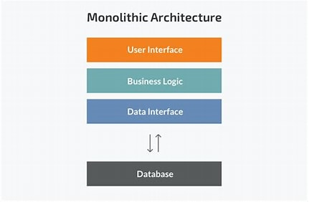

### **Client-Server Architecture**

This segregates an app into a thin client running on the mobile device and the bulk of the app logic encapsulated in a server.

Key Characteristics:

* Stateless client for UI and validation logic
* Stateful server for business logic and data access
* Communication over network protocols

Pros: Easier to scale and maintain. Client complexity reduced.

Cons: Network dependency. Increased latency.

This architecture is the starting point towards modularising complex enterprise apps with extensive server-side logic.

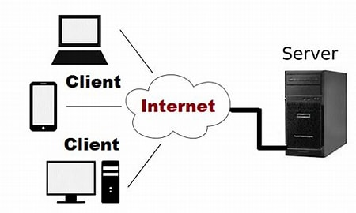

### **MVC Architecture**

The Model-View-Controller ([MVC](https://www.codecademy.com/article/mvc)) is another flavour of client-server architecture tailored to apps with sophisticated UI.

Here’s what each component focuses on:

* Model: Manages data, business logic and state
* View: Renders UI and outputs to display
* Controller: Handles inputs and delegates requests between View and Model

Key Characteristics:

* Strict separation of UI layer from business logic and data access logic
* Suited for complex, interactive UI needs
* Popular variants like MVVM also exist

Pros: Promotes modularity, parallel workflows

Cons: Complex to implement for more superficial apps

MVC is great for e-commerce and workplace apps with rich, dynamic UIs but leaner mobile clients.

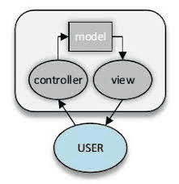

* **Model:**

It represents the data and business logic of the app. It encapsulates the core functionality and data management of the application. This component is responsible for data storage, retrieval, validation, and processing. It responds to requests from the Controller and notifies the View when the data changes.

* **View:**

Its responsibility is to render the [user interface](https://www.octalsoftware.com/blog/mobile-apps-development-mobile-web-development-whats-pick) and present data to the user. It displays the information from the Model to the user in a visually appealing and understandable format.

* **Controller:**

It works like an intermediary between the Model and the View. It receives user input, processes it, and communicates with the Model to retrieve or update data. The Controller decides which View should be displayed to the user based on the user’s actions.

### **Microservice Architecture**

In this distributed architecture style, an app is built as an ecosystem of finer-grained, independently deployable microservices:

Key Characteristics:

* Functionalities split into autonomous services
* Services can be independently developed, tested, deployed
* Individual scaling capability per service
* Communication via APIs

Pros: Highly scalable. Enables continuous delivery.

Cons: Complex to create, orchestrate, test and monitor

Microservices shine for internet-scale apps needing extreme performance, availability and scaling needs. Examples include Netflix, Amazon, and Uber.

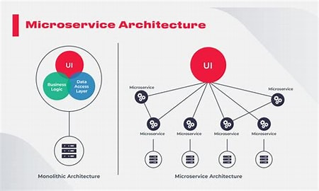

### **Model-View-ViewModel (MVVM)**

Model-View-ViewModel (MVVM) is an architectural design pattern used primarily in software development for building user interfaces. MVVM is especially popular in modern mobile and web applications.

It’s an evolution of the Model-View-Controller (MVC) pattern, designed to enhance the separation of concerns and improve the testability and maintainability of code.

MVVM consists of three main components: Model, View, and ViewModel, each with distinct responsibilities:

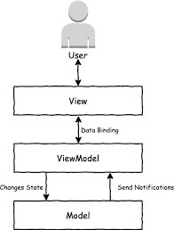

* **Model:**

The Model represents the application’s data and business logic. It is responsible for data storage, retrieval, validation, and processing.

* **View:**

The View represents the user interface and is responsible for displaying data to the user. In MVVM, the View is the visual component of the application, such as a screen in a mobile app or a [web page](https://www.octalsoftware.com/web-development-services) in a web application.

* **ViewModel:**

The ViewModel serves as an intermediary between the Model and the View. It encapsulates the presentation logic, transforms the data from the Model into a format that is suitable for the View, and handles user interactions.

1. **Mobile Application architecture example**

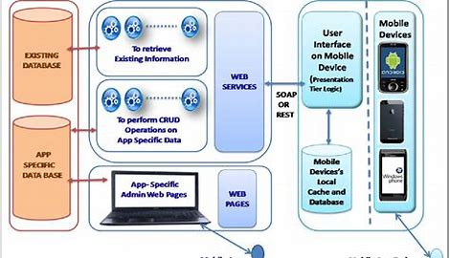

Mobile Application for student information system

* 1. **Design of Mobile Application** 
     + 1. **Mobile App Architecture Diagram: Most Common**

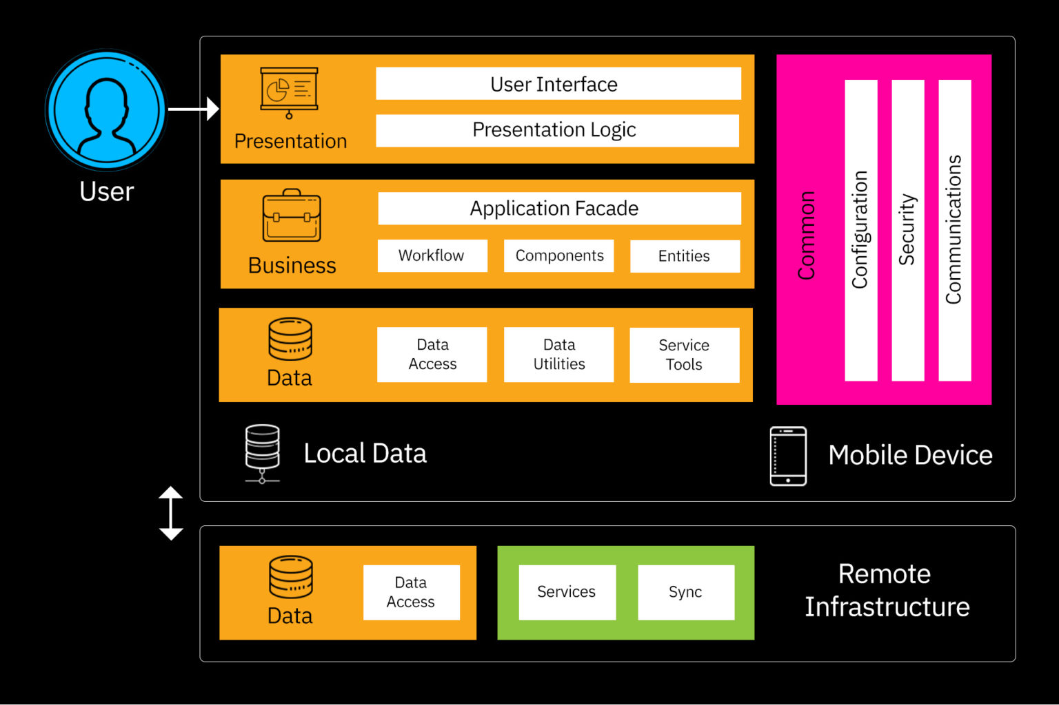

So to design a good mobile application , we need to make sure that all the element of this diagram above appear well on the design .

Now let expect the reason of the presence of each layer on this diagram :

* 1. **Presentation** **layer**
* The presentation layer consists of two components . these two components include the User Interface and UI process . While discussing this layer , the primary focus is the end user’s mobile app’s presentation.
* During the presentation layer stage ,one need is to decide many important things , these include themes , fonts , colours , and shadings .  
  Another important aspect of this layer is to select the correct data format and use of robust data validation mechanisms.
  + 1. **Business layer**
* Business layer is for the elements on the business front . this layer present the business to the end-user and include business components , workflow and entitie.
* This layer is complex ( the security challenge) and has many problem like caching and logging
* It’s broken into two part to reduce the complexity . these include the service layer and domain model

1. **Data Layer**

* The Data Access Layer answer the app need . they offer efficient and secure data transaction . its include data utilities , data access , and service agents.
* The selection of the correct data format is important . having a strong validation technique is another factor that makes it important to design this layer.
* The data are encapsulated in this layer and support CRUD(Create ,Read , Update , and Delete) operation
* Maintenance of the data is important . this practice helps in keeping this layer changeable and scalable with the business requirement.

1. **Factors to consider during Mobile App Designing** 
   1. **Device type**

When designing a mobile app , first choose the platform ( iOS , iPadOS , Adroid , Windows …) , then consider the different models of smartphone that are in use . these are important information to help determine the ideal dimensions for development.

The following device are important to take in consideration :

* Screen resolution
* CPU
* RAM

1. **Developmental Framework**

* Developmental Framework is a consideration in designing the mobile app architecture . Framework provide libraries and basic templates and components for building the mobile app , both for the front and the back-end.
* To make a Front-end frameworks for mobile app we can use Bootstrap , Foundation , React , Angular ,Backbone …etc .
* On the Back-end (server side) ,we can have Flask , Django, Laravel , Swift , Xamarin , React Native , Flutter , …etc

1. **User Interface / User Experience Design (UI/UX Design)**

When it come to mobile app architecture , expect UI (who define how the interface will looks like) and second UX (who define the behavior of the interface) is important to design it . Because it will make easier the interaction between the User and the interface

c- **Navigation**

Navigation is the direct user’s contact with the design , impacting both front-end and back-end . A great mobile UX design helps users easily identify how to move around the page and explore further section

1. **Design of Mobile Application example**

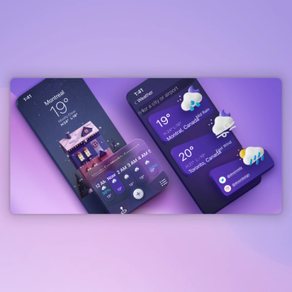  
  **Wheather Apps UI Design**

1. ***Study how to collect and analyse user requirements for a mobile application (requirement engineering)***

**Collecting and analyzing user requirements**

Collecting and analyzing user requirements refers to the process of gathering, understanding, and documenting the needs, expectations, and constraints of users for a particular software system, such as a mobile application. This process is essential for ensuring that the resulting software solution meets the intended purpose and provides value to its users.

Here's a step-by-step guide on how to collect and analyze user requirements for a mobile application:

* Identify Stakeholders:

Determine who the key stakeholders are for the mobile application. This can include end-users, clients, business analysts, developers, designers.

* Gather Initial Information:

Conduct meetings, interviews, surveys, or workshops with stakeholders to gather initial information about the application's purpose, target audience, goals, and objectives.

* User Personas:

Create user personas based on demographic information, behaviors, needs, and goals of the target audience. This helps in understanding who will be using the application and what their requirements might be.

* Document Functional Requirements:

Work with stakeholders to identify and document functional requirements, i.e., what the application should do. This can include features, functionalities, and interactions users expect from the app.

* Document Non-functional Requirements:

Identify and document non-functional requirements such as performance, security, scalability, usability, and regulatory compliance. These are equally important for the success of the application.

* Use Cases and User Stories:

Create use cases and user stories to describe how users will interact with the application and achieve their goals. This helps in understanding the workflow and identifying specific requirements.

* Prototyping and Mockups:

Develop prototypes or mockups of the application to visualize the user interface and gather feedback from stakeholders. This can help in refining requirements based on early user feedback.

* Prioritize Requirements:
  + Prioritize requirements based on their importance, feasibility, and impact on the overall project. This helps in focusing on the most critical features and functionalities during development.
* Review and Validation:

Review the requirements documentation with stakeholders to ensure accuracy, completeness, and alignment with the project objectives. Make necessary revisions based on feedback.

* Traceability and Management:

Establish traceability between requirements and other project artifacts such as design documents, test cases, and code. Use requirement management tools to track changes and ensure consistency throughout the development process.

* Iterative Process:

Requirement engineering is an iterative process, so be prepared to revisit and refine requirements as the project progresses and new information becomes available.

By following these steps, you can effectively collect and analyze user requirements for a mobile application, ensuring that the final product meets the needs and expectations of its users.

1. ***Study how estimate mobile app development cost***

**Estimating Mobile App Development Cost**

**1. Define the Scope**

Clearly outline the features and functionalities of the app, including platforms, user authentication, integrations, and backend requirements.

**2. Choose Development Approach**

Decide between native, hybrid, or cross-platform development based on project requirements and target audience.

**3. Break Down Features**

Divide app features into smaller components or user stories for accurate estimation of effort.

**4. Determine Development Time**

Estimate development time based on feature complexity, discussions with developers, or historical data.

**5. Identify Resources**

Choose between in-house developers, freelancers, or development agencies based on project needs and budget.

**6. Estimate Development Costs**

Calculate costs based on resource hourly rates and estimated development time.

**7. Consider Design Costs**

Allocate budget for UI/UX design based on app complexity and designer rates.

**8. Account for Testing**

Include testing costs for ensuring app functionality and bug-free operation.

**9. Include Maintenance and Support**

Factor in ongoing maintenance and support costs post-launch, including updates and bug fixes.

**10. Contingency**

Allocate 10-20% of the total budget as a contingency for unexpected costs or requirement changes.

**11. Calculate Total Cost**

Sum up estimated costs to arrive at the total development cost.

**12. Review and Refine**

Regularly review and refine cost estimates based on market rates and project progress.

***CONCLUSION***

In conclusion , The choice of app type , programming language and framework depends on factors such as project requirement , target audience , development timeline , and budget considerations . By carefully evaluating these factors and adopting best practices in app development , businesses can create robust , user-friendly mobile apps that resonate with their target audience and contribute to their overall success in the digital marketplace .